**Application Guide to Automate Firmware Upgrades for SEL Software Defined Network Switches**

**PURPOSE**

This application guide and its associated program describes how to automate firmware upgrades for all your SEL-2740S and SEL-2742S Software Defined Network Switches.

This application guide assumes you have an SDN in operation using the SEL-5056 Flow Controller and you desire to firmware upgrade the switches. For the purposes of this guide, we provide an example network configuration. Permission Level 3 Account Login Credentials for SEL-5056 Web Interface are required.

**TEST NETWORK TOPOLOGY**

The demonstration network used for this guide includes seven SEL-2740S switches and one SEL-2742S. We use inband management between all switches and the SEL-5056 Flow Controller but out of band management also works using the same steps detailed in this guide. The firmware upgrade program detailed in this guide is installed on the same computer as the SEL-5056 Flow Controller, but it could be installed on a different computer as long as the two computers are able to network to each other.

**The NETWORK Diagram from SEL-5056 Web Interface**

The figure 1 depicts the network topology diagram from SEL-5056 Web Interface. This shows the connection among the switches and flow controller. Table 1 depicts the network configuration used in this guide. Table 1 also depicts the adoption settings for the SEL-5056, including the adopted IP address and the alias for each switch. The SEL-5056 Flow Controller IP address is 192.168.1.1.

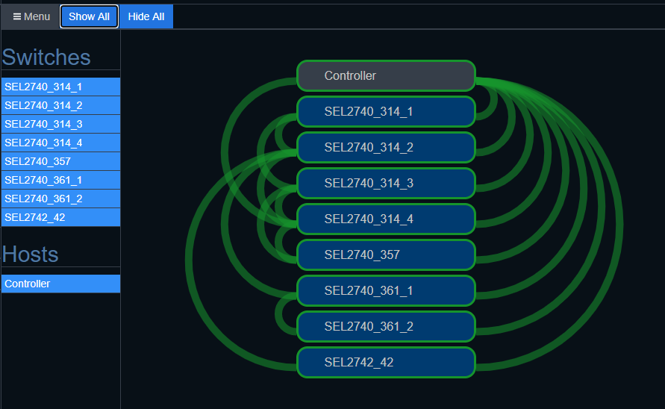

Figure Network Topology Diagram from SEL-5056 Web Interface

Table - Network Configurations and Adoption Settings

|  |  |  |  |
| --- | --- | --- | --- |
| **Switch Name (Alias)** | **Operational Node** | **IP address** | **IP Subnet Mask** |
| SEL2740_314_1 | OpenFlow:00000030A716E50A | 192.168.10.142 | 255.255.0.0 |
| SEL2740_314_2 | OpenFlow:00000030A716E4CC | 192.168.3.14 | 255.255.0.0 |
| SEL2740_314_3 | OpenFlow:00000030A716E1DD | 192.168.3.143 | 255.255.0.0 |
| SEL2740_314_4 | OpenFlow:00000030A716E4F5 | 192.168.3.144 | 255.255.0.0 |
| SEL2740_357 | OpenFlow:00000030A716E419 | 192.168.3.57 | 255.255.0.0 |
| SEL2740_361_1 | OpenFlow:00000030A716E51B | 192.168.3.61 | 255.255.0.0 |
| SEL2740_361_2 | OpenFlow:00000030A716E58F | 192.168.36.12 | 255.255.0.0 |
| SEL2742_42 | OpenFlow:00000030A723FEB8 | 192.168.36.42 | 255.255.0.0 |

**Commissioning the SEL-2740S and SEL-2742S Switches**

The SDN switches can be firmware upgraded before or after adoption. In this example we firmware upgrade after adoption. This simulates the use case that you have a deployed and operational network and then you want to firmware upgrade your switches using an automated method rather than upgrading one switch at a time.

**Installing and running the Firmware upgrade application**

The Firmware Upgrade Application is an executable and no installation is required. Simply copy the executable to the directory location you desire to run it from. Double click the exe file and the application graphical user interface (GUI) window will open

**Firmware Upgrade SDN Switches (SEL-2740S & SEL-2742S) using Automation**

This Firmware Upgrade application is used to automate network wide switch firmware upgrades for the SEL-2740S and SEL-2742S Software Defined Network Switches. There are three steps.

1. Open the Firmware Upgrade Application and enter your Login Credentials (Permission Level 3 Account Login Credentials used during SEL-5056 Web Interface) and hit the Login button.

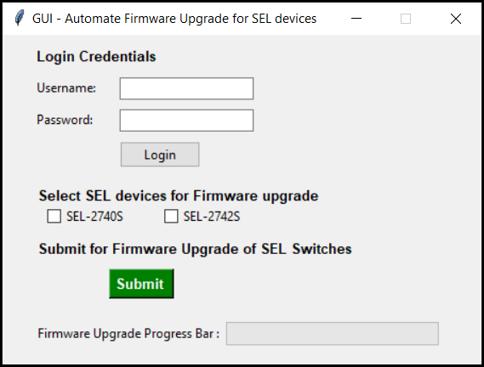

Figure - Firmware Upgrade GUI Application Window

If the login credentials are correct, you will get a popup window – Login Validation Window showing login status of either “Login is successful” or “Username/password is INCORRECT”

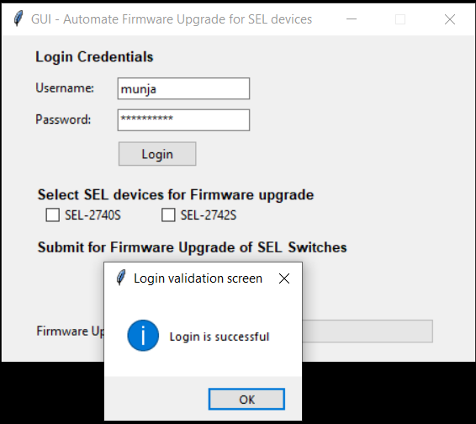

Figure - Login Validation screen

1. Second step is to Select the type of switches you want to upgrade. You may select one or both using the check boxes provided.

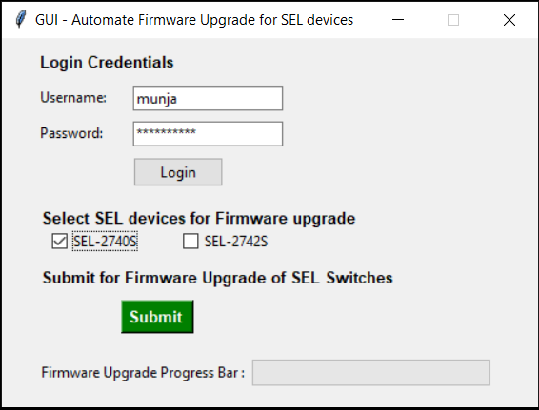

Figure - Check Button options to select SDN Switch

1. Third step is to hit Submit button for Firmware Upgrade. The process will start, and a popup window will appear with the message “Firmware upgrade initiated”. Press OK. A new window will appear to select the Firmware file the application will use for the upgrade. Press Ok and a File Explorer window will appear asking to provide a desired Firmware file. If you selected both types of switches you will have file upload requests for both consecutively. Also, you can see the firmware upgrade progress bar which will show the how much percentage the firmware upgrade process has been completed.You can see the below attached pictures for reference.

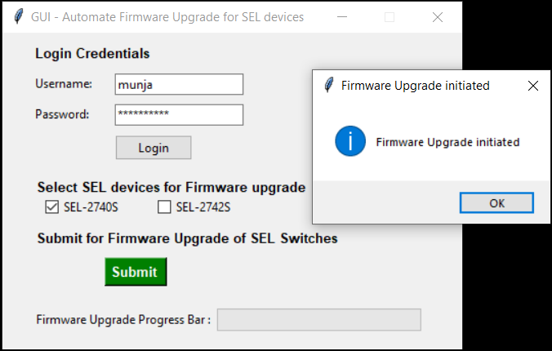

Figure -Firmware Upgrade initiated window

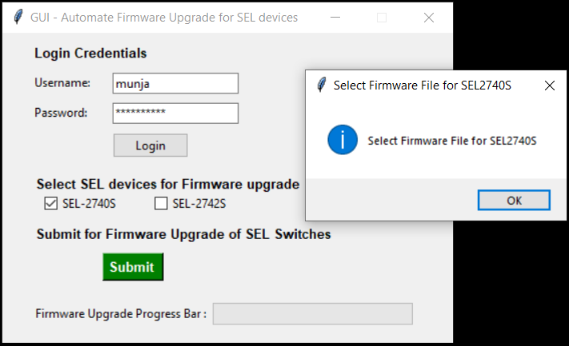

Figure - Select Firmware file window

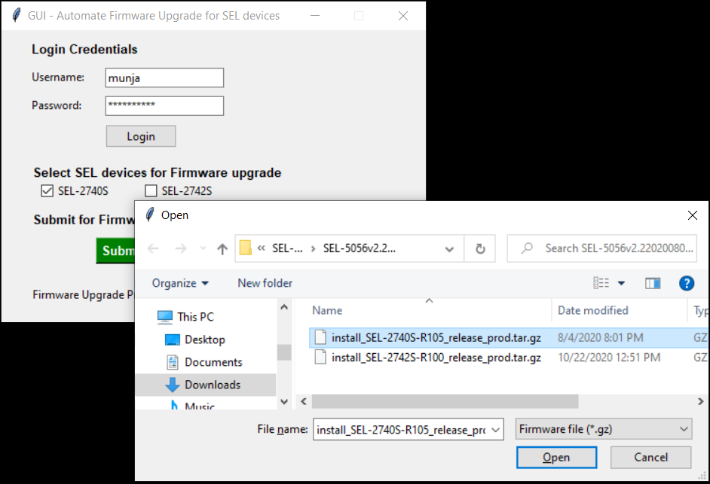

Figure - Select Firmware file path to upgrade

After providing the Firmware files, the application start performing firmware upgrades for all the selected switches.

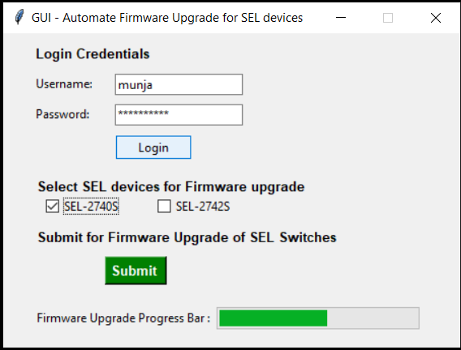

Figure - Firmware Upgrade status window

Once the Firmware Upgrade has been initiated for all selected SDN Switches a popup window lists the SDN switches that were upgraded using the *SDN Switch display name -Alias*. Also, the Progress bar will display as 100 percent complete. It will take a little time to reflect firmware upgrade status on SEL-5056 Web Interface.

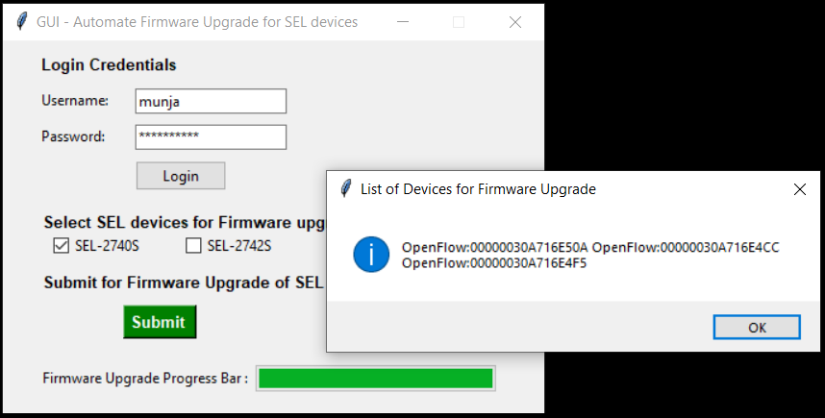

Figure - List of SDN switches for Firmware Upgrade

The firmware upgrade application is complete, and you can check the status of Firmware Upgrade process on SEL-5056 Web Interface.

**CONCLUSION**

This application guide describes how to use an application to automate the firmware upgrade of all of your switches managed by the SEL-5056 Flow Controller.